BA Capstone Project: Checkpoint 2
Spreadsheet & Statistical Analysis

Retail & Sales Analytics: Customer Segmentation & Purchase Behavior Analysis

Course Code / Title | BED 106 — Business Analytics
Checkpoint | Checkpoint 2 — Midterm Period — Weeks 5–9 — 100 Points
Group Name | ________________________
Date | 2026-08-21
Academic Year | 2026–2027, 1st Semester
Instructor | Jessie A. Melendres

Team Members & Roles
- Jeziel Lea Mitch Credo — Project Lead / Analyst & BI Developer / Visualizer
- Nicka Hinlayagan — Data Engineer
- Jennilyn Manatad — Statistician / Modeler

Task 2.1 — Spreadsheet Analytics Report
The full analysis was built in the companion workbook “Checkpoint 2 - Spreadsheet & Statistical Analysis.xlsx”, structured exactly as required:
- Sheet 1 — Cleaned Data: the same 300-invoice, 5,129-line cleaned transaction set used for the Checkpoint 1 database (2010-12-01 to 2010-12-03), with three helper columns identifying completed (non-cancelled) lines for use in the statistics formulas.
- Sheet 2 — Pivot Analysis: three summary tables — Total Sales by Country, Average Unit Price & Revenue by Product (top 15), and Order Count by Hour of Day — built with SUMIFS / AVERAGEIFS / SUMPRODUCT formulas against Cleaned Data.
- Sheet 3 — Pivot Charts: a bar chart of revenue by country, a bar chart of the top 15 products by revenue, and a line chart of order count by hour of day, each titled and axis-labeled.
- Sheet 4 — Formulas Showcase: five functions demonstrated live against Cleaned Data — SUMIF (UK revenue), COUNTIF (cancelled lines), VLOOKUP (product description lookup), IF (High Value/Standard line flag), and TEXT (formatted invoice date).

Cleaned Data
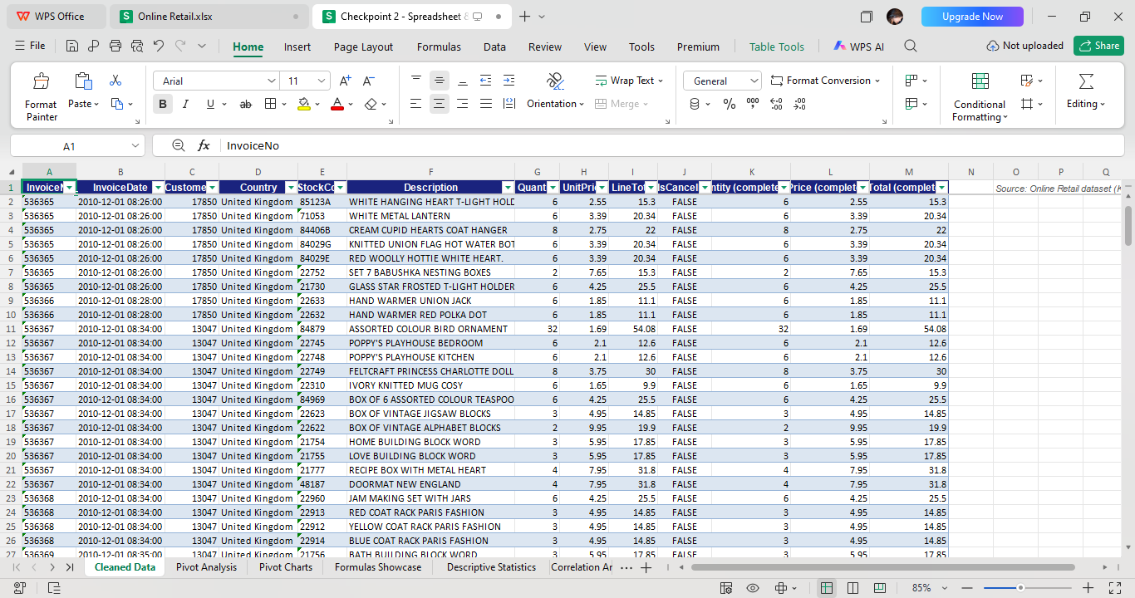
Pivot Analysis
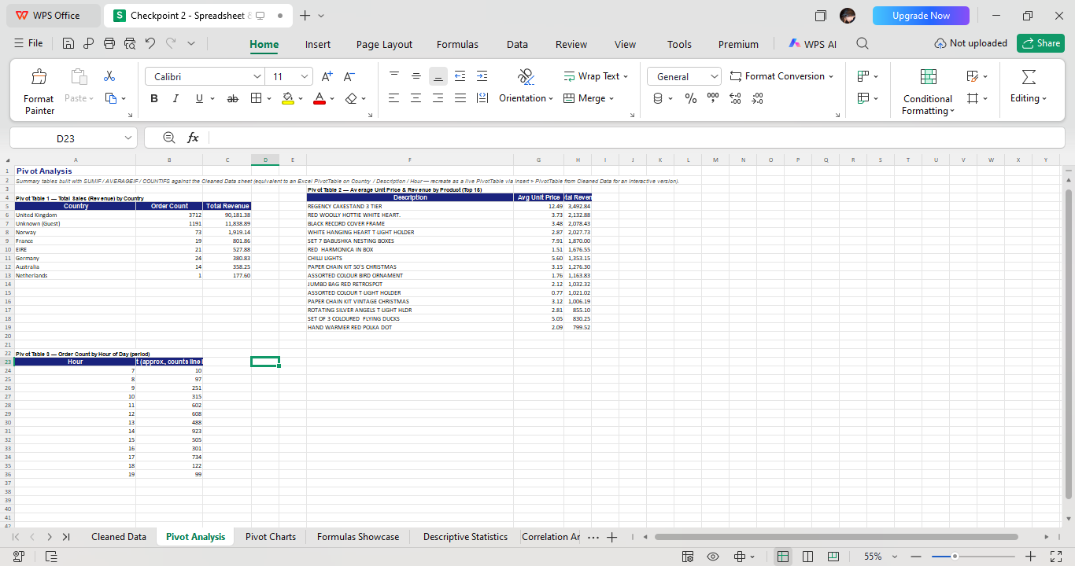

Pivot Charts

Formulas Showcase
Five Excel functions applied to the Cleaned Data sheet, each with a live formula.
- SUMIF — total revenue from United Kingdom orders
- COUNTIF — number of cancelled order lines
- VLOOKUP — look up a product's description from its StockCode
- IF — flag each sample line as High Value (>= £15) or Standard
- TEXT — format the invoice date as a readable string

Task 2.2 — Descriptive Statistics Report
Computed on the 5,055 completed (non-cancelled) order lines in the sample (see the Descriptive Statistics sheet in the workbook):
Statistic | Quantity | Unit Price (£) | Line Total (£)
Mean | 11.61 | 3.54 | 21.01
Median | 3.00 | 2.51 | 10.20
Mode | 1.00 | 1.25 | 15.00
Std. Deviation | 58.30 | 6.04 | 60.80
Variance | 3,399.44 | 36.49 | 3,696.18
Range | 2,879.00 | 294.90 | 1,626.91
Min | 1.00 | 0.10 | 0.29
Max | 2,880.00 | 295.00 | 1,627.20

Quantity
The mean quantity per order line (11.6 units) is far above the median (3 units) and the mode (1 unit), and the standard deviation (58.3) dwarfs the mean itself — a strongly right-skewed distribution. Most order lines are small (a third of all lines are a single unit), but a handful of bulk purchases (up to 2,880 units on one line) pull the average up sharply. For inventory planning, this means typical basket size should be estimated from the median/mode, not the mean, while bulk orders should be tracked and fulfilled as a separate operational category.

Unit Price
Unit prices are modest and tightly clustered: the median (£2.51) and mode (£1.25) sit close together near the low end of a £0.10–£295.00 range, with a mean of £3.54 pulled upward by a small number of premium items. This confirms the business's core catalog is low-cost novelty/gift items, with a long tail of higher-priced décor pieces (e.g., the £295 top price) that likely drive disproportionate margin per unit sold.

Line Total
Line total (Quantity x Unit Price) mirrors the skew seen in Quantity: mean £21.01 versus median £10.20, with a maximum single line value of £1,627.20. This tells the business that a small number of large order lines materially affect total revenue, so revenue forecasts built only on “typical” order size will understate real totals — bulk-order variance needs to be modeled explicitly rather than smoothed away.

Frequency Distribution — Quantity per Order Line
Quantity Bucket | 1 | 2 | 3–5 | 6–10 | 11–25 | 26–50 | 51–100 | 100+
Order lines | 1509 | 700 | 730 | 814 | 981 | 175 | 81 | 65

The histogram (Descriptive Statistics sheet) confirms the right-skew directly: frequency drops off steadily from single-unit lines toward the 26–50 and 51–100 buckets, with a small but non-trivial resurgence of 65 lines above 100 units — the bulk-order segment worth tracking separately.

Task 2.3 — Correlation Analysis

Pair 1 — Quantity vs. Unit Price (line-item level)
Pearson r = -0.0572 (CORREL, Descriptive/Correlation Analysis sheet). This is a very weak negative correlation, essentially no linear relationship: customers do not reliably buy less of an item because it costs more, at this price range. Business implication: price alone is a poor predictor of order size in this catalog — quantity purchased is driven more by occasion/bulk-buying behavior than by unit price sensitivity.

Pair 2 — Items per Invoice vs. Invoice Value
Pearson r = 0.6912 (n = 271 invoices). This is a moderately strong positive correlation: invoices with more distinct line items reliably carry a higher total value. Business implication: basket-size (cross-sell / upsell of additional line items) is a meaningfully more reliable lever for growing revenue per order than trying to push customers toward higher-priced individual items.
The scatter plot with linear trendline and R²/equation is embedded directly in the Correlation Analysis sheet next to the Pair 2 data table.

Task 2.4 — Simple Linear Regression
Dependent variable (Y): Invoice Value (£). Predictor (X): Items per Invoice.
Regression equation: Invoice Value = 217.49 + 9.35 × (Items per Invoice)
Metric | Value
Slope (b) | 9.346
Intercept (a) | 217.492
R-squared | 0.4777
Correlation (R) | 0.6912
p-value (slope) | < 0.0001 (highly significant)
n (invoices) | 271
Predicted value, X = 10 items | £310.95

Interpretation: about 47.8% of the variation in invoice value is explained by the number of items on the invoice (R² = 0.478); the remaining ~52% comes from other factors such as which specific products were bought. The slope's p-value is far below 0.05, so the relationship is statistically significant — it is very unlikely to be due to chance. Practically: every additional line item added to a basket is associated with about £9.35 more in invoice value, and even a zero-item invoice has a £217.49 baseline intercept driven mostly by a few very large single-item bulk orders in the sample (see Task 2.2 — Quantity outliers), which inflates the intercept and should be read with that caveat rather than as a literal “base order value.”

Limitations & Conditions for Use
- The intercept is inflated by a handful of very large bulk-order line items identified in the descriptive statistics; a robust/outlier-trimmed regression would likely show a lower intercept and a steeper, more representative slope.
- The model is a simple (single-predictor) regression — it does not control for product mix, country, or day/hour of purchase, all of which plausibly also affect invoice value.
- The sample covers only 271 invoices over roughly 3 days from a single retailer; the equation should not be assumed to generalize to a different sales period or business without re-fitting.
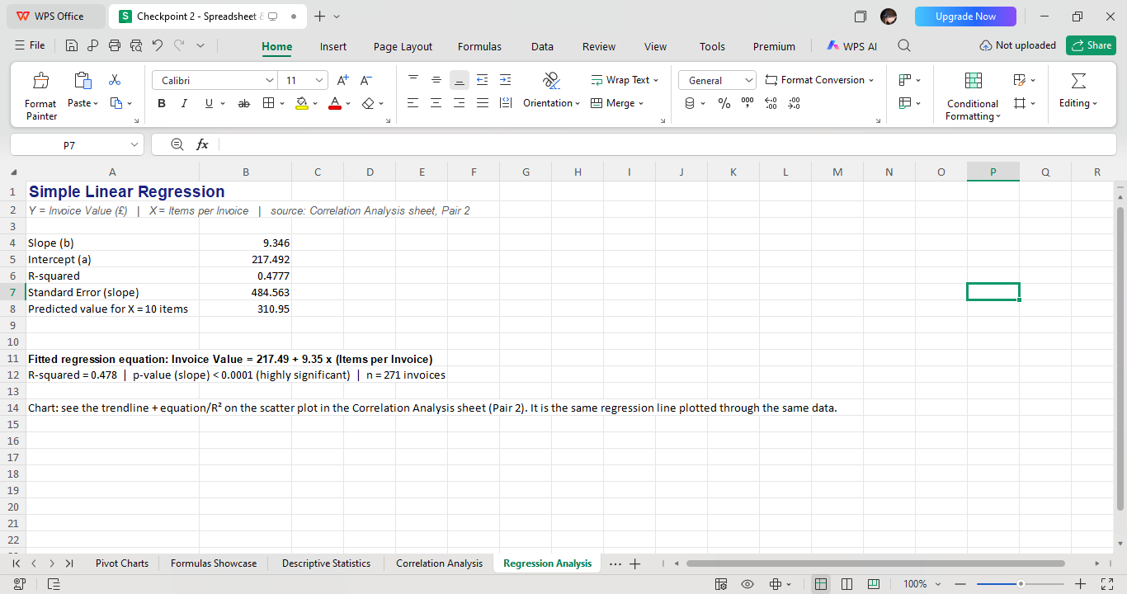

Task 2.5 — Trend / Seasonality Analysis
The sample is time-stamped at the minute level, so an hourly revenue trend was built across the full window (2010-12-01 08:00 to 2010-12-03 09:00, 24 hourly buckets).
Linear trend fit: Revenue = 5,500.50 − 93.57 × t | R² = 0.047, p = 0.31 (not statistically significant).
FORECAST-based projection for the next 3 hourly periods: £3,254.75, £3,161.18, £3,067.60 (Trend Analysis sheet, cells B31:B33).

Reliability & Assumptions
With only ~24 hourly observations spanning under 3 calendar days, the day-over-day linear trend is not statistically reliable (p = 0.31, well above the 0.05 significance threshold) — the forecast above should be treated as illustrative only, not a dependable business projection. The more trustworthy pattern in this sample is the intraday order curve visible in Pivot Chart 3 (Order Count by Hour of Day): orders build steadily from shop opening, peak around midday to early afternoon (hours 12–16), and taper off by evening — a staffing/response-time planning signal, not a long-range sales forecast. A genuine month-over-month or seasonal trend/forecast would require extracting a full year of the same source dataset (which spans 2010-12-01 to 2011-12-09) rather than the 3-day Checkpoint 1 sample.

